Lesson 06 XAS Resource Workbook

**Fluorescence Mode, Self-Absorption, and Inverse Fluorescence**

**Charles A. Cardot and Gerald T. Seidler**

*All lessons and all versions can be found at* [*https://github.com/XASResourceWorkbook/XASResourceWorkbook*](https://github.com/XASResourceWorkbook/XASResourceWorkbook)

*This work is licensed under* ***CC BY-NC-SA 4.0***

**

Version History:

1.0 May 2021: C.A. Cardot, G.T. Seidler

Lesson 06 XAS Resource Workbook

**Fluorescence Mode, Self-Absorption, and Inverse Fluorescence**

**Suggested Introductory Reading**

* Newville (Section 4) A detailed first introduction to fluorescence mode measurements, geometry, filters, and self-absorption, <https://doi.org/10.2138/rmg.2014.78.2>
* Calvin and Furst. *XAFS for Everyone* (pg. 61-67) ISBN-13: 978-1439878637. This section provides a good qualitative and intuition-based explanation of the various self-absorption edge cases for thick/thin and dilute/concentrated samples.

**Overview and Advanced Reading**

Fluorescence mode measurements are used for samples where the target species is very dilute or where transmission mode is impossible for samples-specific reasons. Here are some examples:

* One of the first papers to discuss the expansion of XAFS to dilute samples via fluorescence detection was Jaklevic, et al., Sol. State. Comm. **23** 679 (1977) <https://doi.org/10.1016/0038-1098(77)90548-8>.
* Metalorganics are frequently studied by fluorescence mode EXAFS to determine the local environment around the metal ion. Two early examples are: (1) Slater, et al, PNAS **88** 325 (1991) <https://doi.org/10.1073/pnas.88.2.325> used EXAFS as an important piece of a study that isolated the structure of ‘malaria pigment’, one of the waste products of the malaria parasite, and (2) a study of EXAFS from the photosystem II protein responsible for most photosynthesis on Earth helped to constrain models of the critical cluster of four Mn atoms whose redox chemistry is driven by sequential photoexcitation to execute the photosynthetic process itself, see Yachandra, et al, Science **260** 675 (1993) <https://doi.org/10.1126/science.8480177>. Two videos describing research XAFS applied to metalorganics are <https://www.youtube.com/watch?v=kZgOan8mQ7s> and <https://www.youtube.com/watch?v=P0FBBp_fIDU>.
* Environmental problems involving metal contamination quite commonly finds dilute species in matrices having strong background x-ray absorption. In environmental geosciences the speciation of heavy elements to determine oxidation state, which can have a strong influence on toxicity, is then often performed by fluorescence mode XAFS. In Foster, et al., American Mineralogist **83** 553 (1998)
* <http://www.minsocam.org/MSA/AmMin/TOC/Articles_Free/1998/Foster_p553-568_98.pdf> fluorescence mode data from the environmental samples was used to determine the ratio of 3+ and 5+ oxidation states of arsenic in mine tailings and also details of the minerals whose surfaces adsorbed the As contaminants.
* The high brilliance of synchrotron light sources allows microfocus XAFS studies that can be used to isolate small portions of large samples. In such cases, the sample details are often not conducive to transmission mode study. A case in point is given by nuclear forensics XAFS work, for example Crean, et al., Enviro. Sci. and Tech. **48** 1467 (2014) <https://doi.org/10.1021/es403938d> Another example is in the study of mineral inclusions, such as for measuring elemental oxidation state to infer formation conditions of lunar rocks returned by the Apollo mission, see Brounce, et al., American Mineralogist **104** 307 (2019) <https://doi.org/10.2138/am-2019-6804> and the video <https://www.youtube.com/watch?v=WBSMS79pBYg>. Finally, such microprobe studies are also often applied to cultural heritage items, such as artwork, see the video <https://www.youtube.com/watch?v=w7HWD_gTYG4>.
* The ability to microfocus the incident synchrotron beam also enables characterization of very small samples in extreme environments, such as high-pressure cells and/or under laser shock conditions. For an overview and a description of a new beamline at the European Synchrotron Radiation facility dedicated to this type of study, see the video <https://www.youtube.com/watch?v=4UkWdGV8F0I>.
* For many lower-energy x-ray studies it can be prohibitively difficult to prepare samples that are thin enough for transmission mode operation. Consequently, fluorescence mode (and total electron yield) are quite common and many lower-energy beamlines rely on it – see for example a beamline at NSLS-II in Northrup, J. Synch. Rad. **26** 2064 (2019) <https://doi.org/10.1107/S1600577519012761> and explained in a video at <https://www.youtube.com/watch?v=ZjNNBf0ctyM>.

As explored in more detail in the Lesson, fluorescence mode detection faces some challenges. First, if the sample is too concentrated then the simplest connection between the detected fluorescence count rate and the core-shell ionization rate breaks down. This ‘self-absorption’ must be addressed with corrections, such as discussed in the documentation for Haskel’s frequently used FLUO algorithm, <https://www3.aps.anl.gov/haskel/FLUO/Fluo-manual.pdf> or in the paper Booth, et al., Physica Scripta, **T115** 2005, p. 202, <https://doi.org/10.1238/physica.topical.115a00202>.

In some cases, the presence of a second lighter element in a sample gives an alternative detection scheme, called ‘inverse partial fluorescence yield’ (IPFY), that seeks to eliminate the need for any self-absorption correction. This was introduced in Achkar, et al., Phys. Rev. B **83**, 081106 (2011), <https://doi.org/10.1103/PhysRevB.83.081106>. An illustrative example of the use of IPFY is in soft x-ray studies of battery materials, Dai, et al., Joule **3**, 518 (2019) <https://doi.org/10.1016/j.joule.2018.11.014>.

From an experimental perspective, fluorescence mode detection allows for a variety of approaches. The classic detection approach, still in common use, is often called a ‘Lytle detector’ or ‘Stern-Heald detector’, see Stern and Heald, Rev. Sci. Instrum. **50**, 1579 (1979), <https://doi.org/10.1063/1.1135763>. Solid state detectors, such as silicon- or germanium-based detectors, can give good enough energy resolution to strongly reject backgrounds. As an extreme example, a beamline at Stanford Synchrotron Radiation Laboratory has a 100-element Ge detector to vastly enhance sensitivity for extremely dilute samples, <https://www-ssrl.slac.stanford.edu/content/beam-lines/bl11-2>. This detector was used in the EXAFS study that first demonstrated a coordination complex incorporating the rare and highly radioactive element einsteinium, see Carter, et al., Nature **590** 85 (2021) <https://doi.org/10.1038/s41586-020-03179-3>. Bragg- or Laue-configuration analyzers are sometimes used to filter strong background signals when looking at dilute samples. For a detailed discussion of bent Laue analyzers see Karanfil, et al., J. Synch. Radiation **19** 375 (2012) <https://doi.org/10.1107/S0909049512003937>. Finally, at the cutting edge of technical development, superconducting transition edge sensor (TES) arrays are emerging at synchrotron and XFEL sources around the world. TES give the high quantum efficiency of solid-state detectors with an energy resolution approaching that of crystal analyzers. An introduction to this technology is Morgan, Physics Today **71**, issue 8 p. 28 (2018) <https://doi.org/10.1063/PT.3.3995> and the video <https://www.youtube.com/watch?v=uOHDkgdWIuw>.

## **I. Introduction to Fluorescence mode**

**Educational Goals**: Be able to explain the relationship between the measured fluorescence from thin samples and the absorption coefficient, and explain the relevance of the polarization of the incident beam and how it influences experiment design.

1. In the figure below, label how the apparent incident intensity is changing as the sample penetrates through successive ‘layers’ of the sample of thickness . Do **not** assume that is small.

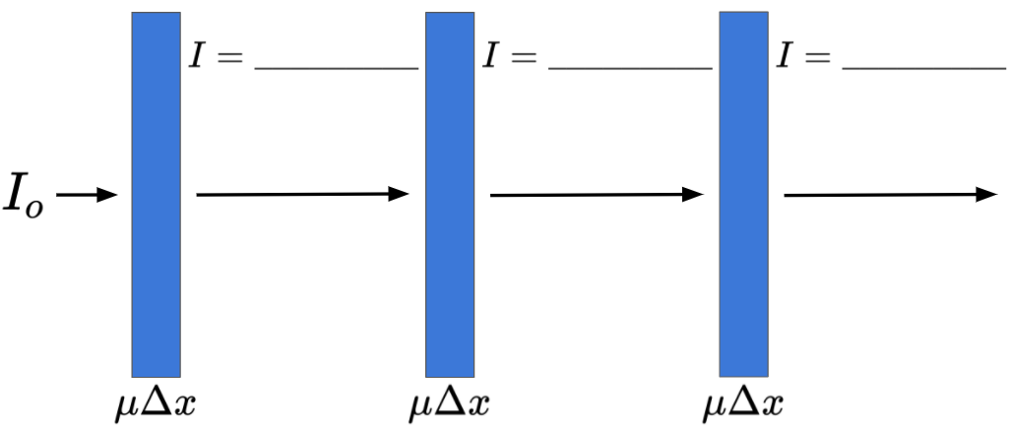

1. Repeat the previous problem, but in the limit of very small , where now we call it . Perform a Taylor series expansion of the exponential in Beer’s law to linear order in . Show that in this limit, the total sample absorption is proportional to .
2. Consider the limit of small for a sample where the absorption is dominated by the one shell of interest of the element of interest. In that case, **why** is the x-ray fluorescence of the relevant element proportional to the sample absorption and its absorption coefficient? The fraction of absorbed photons resulting in fluorescence is called the ‘fluorescence yield’. You can find these values in many places, including for each element in the ‘x-ray periodic table’ a <http://www.csrri.iit.edu/periodic-table.html>. Which edges have the highest fluorescence yield?
3. Shown below is a schematic for classical scattering of a planar, polarized electromagnetic wave from an object much smaller than the wavelength of the radiation. For each case, roughly sketch the resulting scattered radiation field, or alternatively sketch something about the intensity as a function of direction for the scattered field.

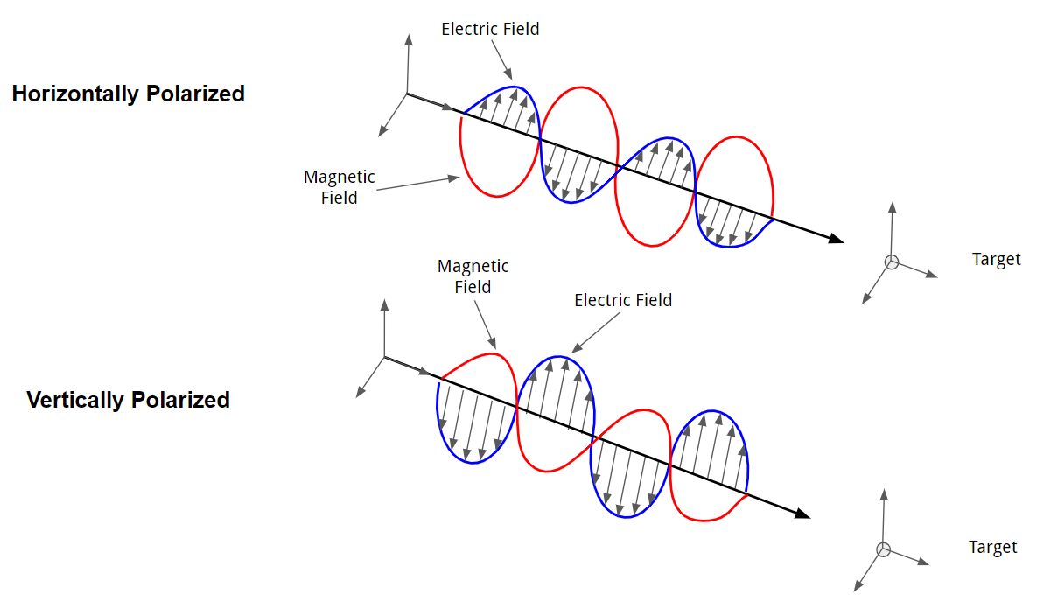

1. Based on your solution to the previous question, consider the figure below and explain the choice to place the detector at a 90-degree angle with respect to the direction the x-ray beam is traveling. Note that the x-ray beam is linearly polarized in the plane of the page. If the incident beam was instead polarized out of the page, how would the detected signal be different?

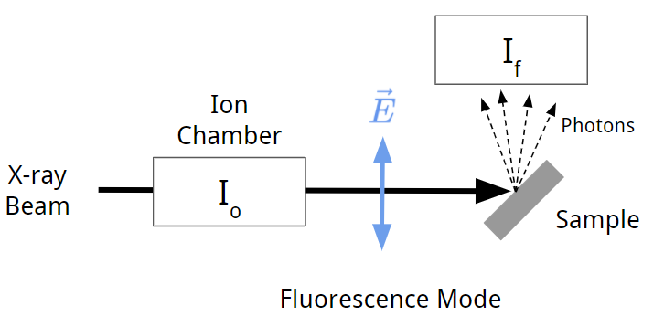

1. Find three papers that use ‘total fluorescence yield’. What were the concentrations of the target species in these papers? How do these concentrations compare to the concentrations of species used in transmission mode? Were there any concentrated species that gave background fluorescence in those studies? What detectors were used?

II. Self-Absorption

**Educational Goals:** Develop a qualitative understand of the causes of self-absorption effects, including especially the role of the energy dependence of the penetration depth in changing the effective sample volume.

1. Consider the expression you derived earlier for the fluorescence mode intensity. What if **is not** very small? When you include the linear and quadratic terms in the Taylor expansion of Beer’s law in orders of , do you still find that the fluorescence signal is proportional to ? Perform the expansion below, including both the linear and quadratic terms. This is the cause of the limitation that is commonly called “the self-absorption effect” or the “over-absorption effect” in fluorescence-mode XAFS.
2. The figure below shows the attenuation of an x-ray beam as it passes through a concrete sample. The blue, green, and red curves all represent different incident x-ray energies, and are thus each attenuated differently. Find both the attenuation length and absorption coefficient of the sample for the three different curves shown. Recall that the attenuation length is related to the absorption coefficient by . (Note: The terms attenuation length, absorption length, and penetration length are often used somewhat interchangeably to refer to .)

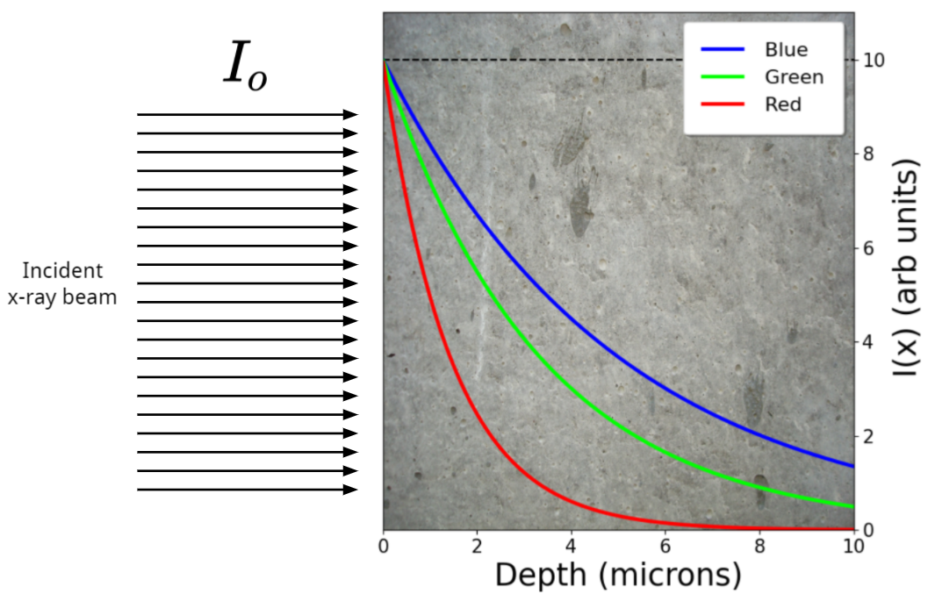

|  |  |  |  |
| --- | --- | --- | --- |
|  | Blue | Green | Red |
| (attenuation length) microns |  |  |  |
| (absorption coefficient) microns-1 |  |  |  |

1. Generally, why is self-absorbance a concern for fluorescence mode measurements? Consider the relationship between the number of fluorescing atoms and the concentration/thickness of the sample.

1. The left figure below shows the absorption coefficient for (hypothetically) the K-shell of some pure element. On the right, show what you expect the experimental fluorescence intensity will be if the sample is extremely thick. To simplify, ignore the absorption of fluorescence within the sample itself.

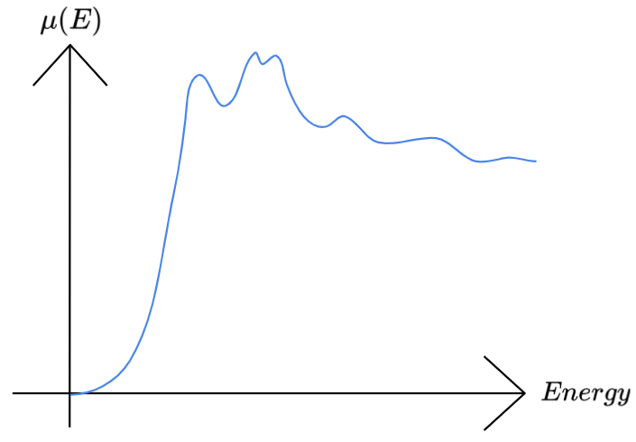 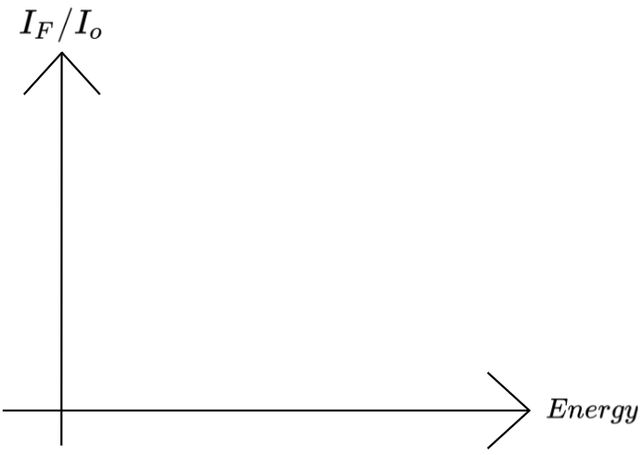

1. Often, the element of interest is not the only element present in the sample. Additionally, the experimental geometry plays a role in the relationship between the detected fluorescence intensity and the sample absorption. See Newville (Section 4) for more information**.** A more accurate form of the equation for fluorescence intensity is given below, where the angles theta and phi correspond to the diagram. In this equation, is the fluorescence efficiency, is the thickness of the sample, is the solid angle of the detector, is the energy of the fluorescence x-ray photon, is the absorption from the element of interest, as opposed to which is the total absorption from all elements in the sample.

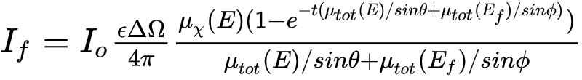 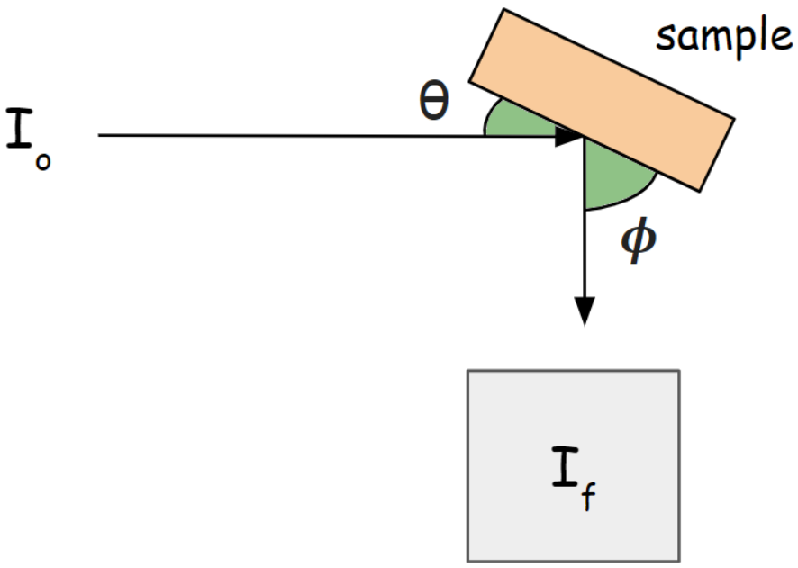

The trigonometric functions allow the expression to adapt to the changing length of absorbing paths as the sample is tilted. From the question, explain why should be expected to appear in the denominator? (Hint: Recall that penetration length and absorption coefficient are inversely related. Why should the fluorescence intensity be proportional to the penetration length?)

1. There are three important limiting cases to the complete equation given at the beginning of the previous problem. For each of these, describe any resulting simplifications and describe whether the measured is, or is not, simply related to the desired quantity, .
   1. the thin dilute sample limit, where
   2. the thick, concentrated-sample limit, where and .
   3. the thick, dilute-sample limit, where but .
2. There are a few algorithms that can be used to compensate for self-absorbance in fluorescence mode data from thick, concentrated samples. Athena is a computational tool commonly used for processing XAS data and has implemented some of these algorithms <https://bruceravel.github.io/demeter/aug/process/sa.html> including the Booth algorithm. Read through the paper <https://doi.org/10.1238/Physica.Topical.115a00202> detailing how the Booth algorithm works, and qualitatively describe what approximations it makes. Where does the approximation begin to break down (require a large correction factor)? What is one of the main advantages of the correction factor in this approximation over others?

III. Energy resolution and filters

**Educational Goals:** Become familiar with detector options, especially in the context of rejecting elastic scatter and fluorescence from other elements in the sample. An understanding of the principles and practice for the Z -1 filter will be developed.

1. Given that most samples being measured in fluorescence mode can include fluorescence from many different elements, why is energy resolution important for a fluorescence detector?
2. The table below is comprised of the Kα1 emission energies, 1s-shell binding energies, and 2p3/2-shell binding energies for a few 3d transition metals. Fill in the missing entries. The Kα1 transition corresponds to a 2p3/2 → 1s transition. The very last row in the table is for the energy difference between the 2p3/2 and 1s shells. Fill this in as well after you have completed the first three partially filled rows. Do the energy differences between the 2p3/2 and 1s shells match the energies of the Kα1 emissions for the various 3d transition metals, or is there some small discrepancy? If not, briefly explain *why* they do not match.

|  |  |  |  |  |  |  |  |
| --- | --- | --- | --- | --- | --- | --- | --- |
| Element | Ti | V | Cr | Mn | Fe | Co | Ni |
| Z | 22 | 23 | 24 | 25 | 26 | 27 | 28 |
| 1s (keV) | 4.966 |  | 5.989 | 6.539 | 7.112 |  | 8.333 |
| 2p3/2 (keV) | 0.4538 |  | 0.5741 | 0.6387 |  | 0.7781 | 0.8527 |
| Kα1 (keV) | 4.511 | 4.952 |  |  |  | 6.930 |  |
| 2p3/2 – 1s (keV) |  |  | 5.4149 | 5.9003 |  |  | 7.4803 |

1. Consider the table you just completed in the previous problem. On the left in the figure below the 3d transition metal Kα1 emission lines and 1s binding energies are represented as bricks organized into a random stack. Given the values you just used to fill out your table, rearrange the stack so that is organized, ascending in energy. The highest and lowest brick positions have already been filled out to get you started.

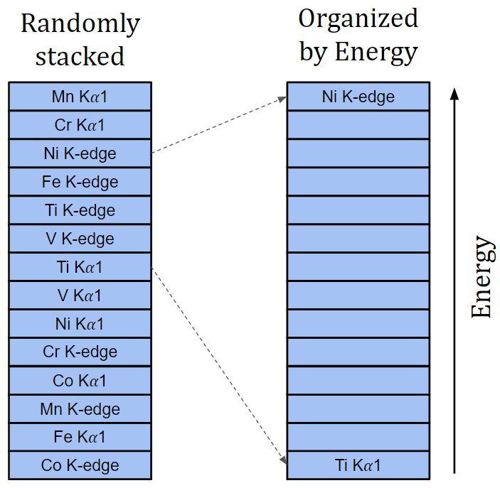

1. Consider the table and the stack you completed in the previous two problems. You may have noticed that there is a pattern where the Z-1 K-edge energy is slightly above the Z Kα1 emission energy for the 3d transition metals that we have looked at. This is ideal for situations in which there is a large scattering background emission line. Imagine a situation in which you are measuring the Kα emission of Co at 6.93 keV, but there is a large amount of scattering background at energies ≥ 7.20 keV. You could place a sheet of a single pure 3d transition metal, namely Fe, in between your Co Kalpha source and your detector to “filter out” the scattering background. A depiction of this is shown in the figure below.

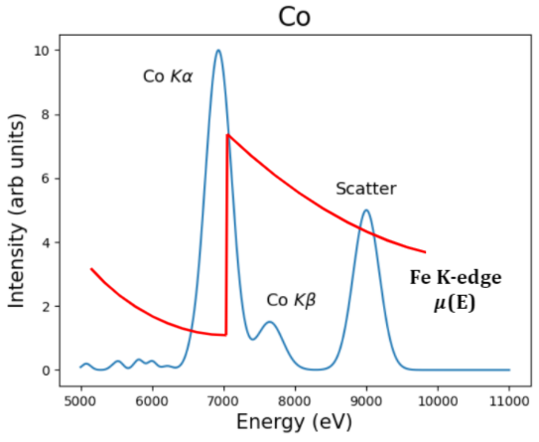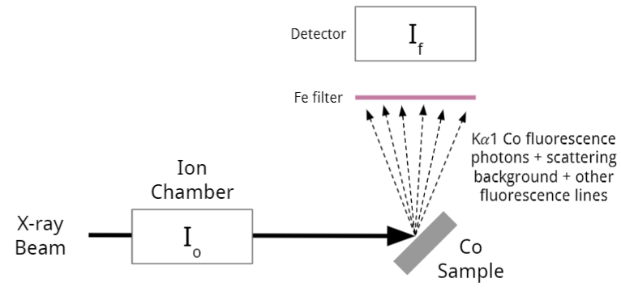

This works because the Co Kalpha radiation will not be as strongly absorbed as it passes through the filter, compared to the scattering background, as shown in the plot of the Co fluorescence and the Fe K-edge absorption coefficient. This concept is explained in more detail in the Stern & Heald paper <https://doi.org/10.1063/1.1135763> . Using the stack and table you completed from the previous two problems, assign the appropriate Z-1 filter to each Kα1 emission energy of each transition metal. In the table below, fill in the correct filter choice for each Kα1 emission which you may want to study.

|  |  |  |  |  |  |  |  |
| --- | --- | --- | --- | --- | --- | --- | --- |
| Emission Line | Ti Kα | V Kα | Cr Kα | Mn Kα | Fe Kα | Co Kα | Ni Kα |
| Filter |  |  |  |  |  |  |  |

1. The effect of a filter is most obvious when directly comparing the absorption coefficient of the filter and the target fluorescence. The four plots below show a representative energy dispersive spectrum taken during XAFS study of the indicated elements. For each plot, choose a filter and *roughly* plot (and label) the corresponding absorption coefficient on top of the fluorescence plot. The first one has been completed for you as an example.

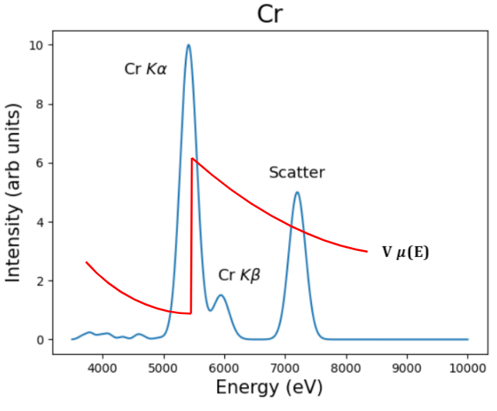 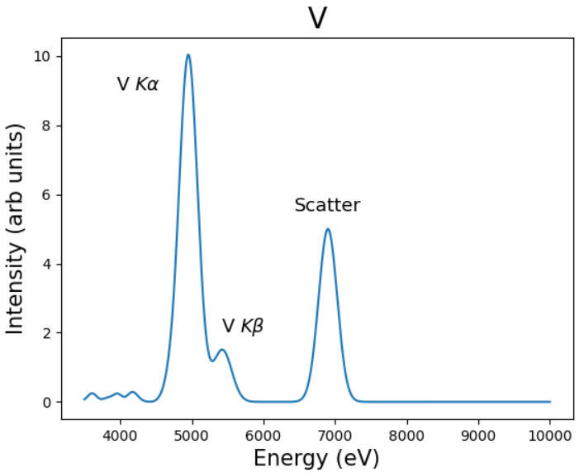

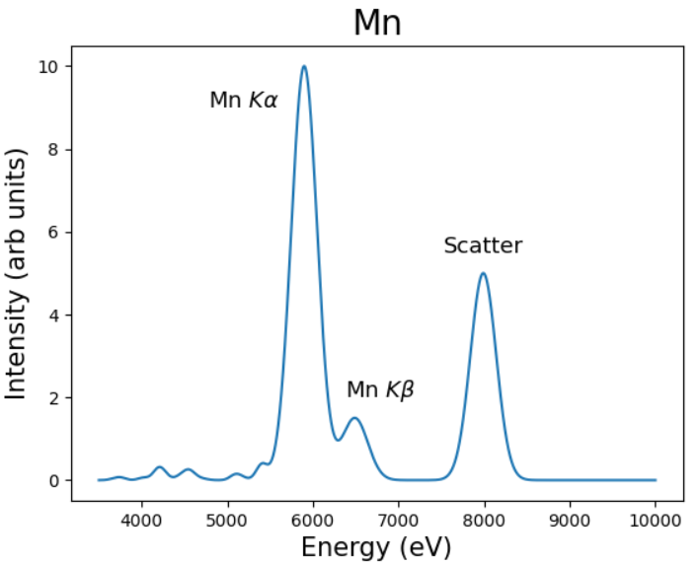 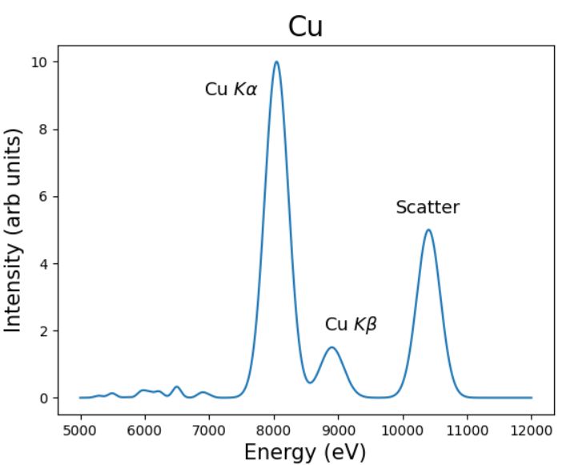

1. The Z-1 filter will also give off its own fluorescence that could reach the detector, and for very dilute samples the detected ‘refluorescence’ from the filter material can still dominate the desired signal. This can be accounted for with Soller slits of a strongly absorbing material.
   1. In the figure below, roughly what fraction of ‘refluorescence’ photons from the filter make it to the detector? What fraction of high-energy photons absorbed by the K-shell of the Z-1 filter typically emit K-shell fluorescence?

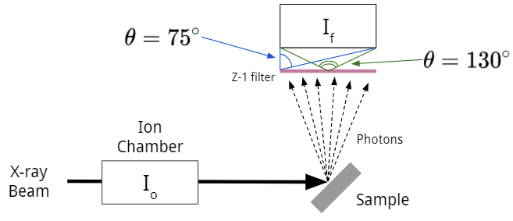

* 1. Now Soller slits have been added to the experimental setup. For students who have not encountered these devices before, Soller slits, also known as a Soller collimator (<https://en.wikipedia.org/wiki/Collimator>), is a general term used to describe various collimated metal slits. See <https://doi.org/10.1063/1.1135763> for more information about an early application of Soller slits to the device shown in the diagram below. Explain why the slits have the alignment shown in the figure below. How does the fraction of ‘refluorescence’ photons which make it to the detector compare to the previous problem?

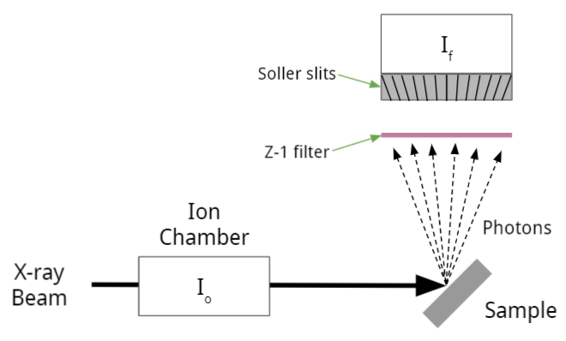

1. Even with the physical filter and Soller slits, why might it still be necessary to have some sort of energy discrimination in the form of a solid-state detector?
2. What are the advantages and disadvantages of using an ionization chamber as opposed to a solid-state detector (such as a silicon drift diode, SDD)? As a special case, suppose you were studying the Cu EXAFS for Fe0.99Cu0.01 alloy. Which detector would be preferred in this case? Would the same be true if you were studying the Fe EXAFS for a Fe0.1Cu0.9 alloy? (Hint: In which case does the ‘other’ element give a strong background fluorescence?)

IV. Inverse Partial Fluorescence Yield Mode

**Educational Goals:**  Build on previously developed understanding of self-absorption as being due to an energy-dependent sampling depth to gain appreciation for the inverse partial fluorescence yield (IPFY) approach.

1. Consider a sample composed of a thick, solid block of Cu with dilute Ti, such as the one shown in the figure below (Cu is blue, Ti dopants are black dots). Based on what we have learned so far about fluorescence mode measurement, will it be easier to reliably measure the EXAFS of Cu or of Ti? Why?

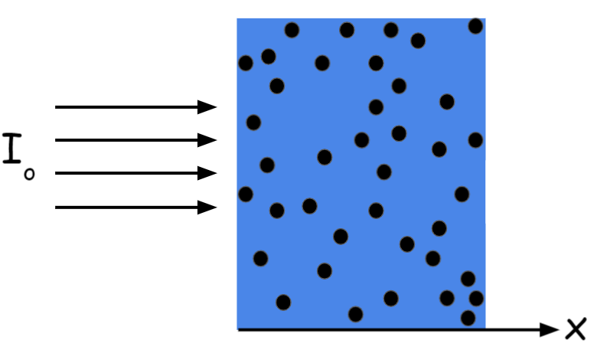

1. Consider the previous experiment, and assume that the sample is so thick, that all the incident x-rays get absorbed. How does the attenuation length (penetration depth) change as the incident x-ray beam energy is scanned across the Cu K-edge? Which element in the sample dominates this effect?
2. 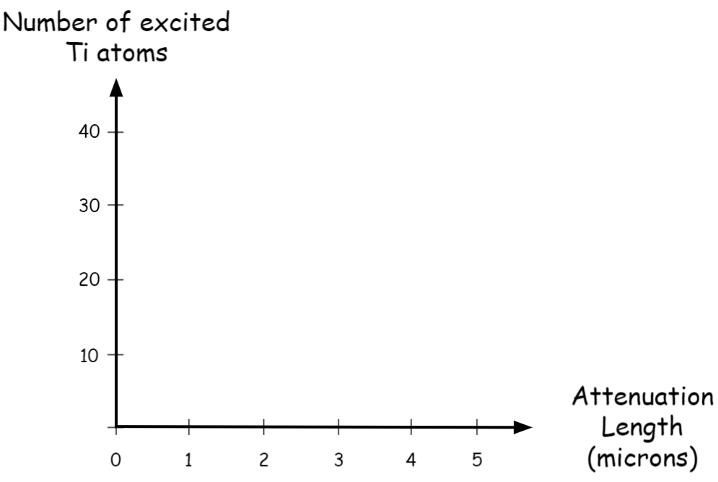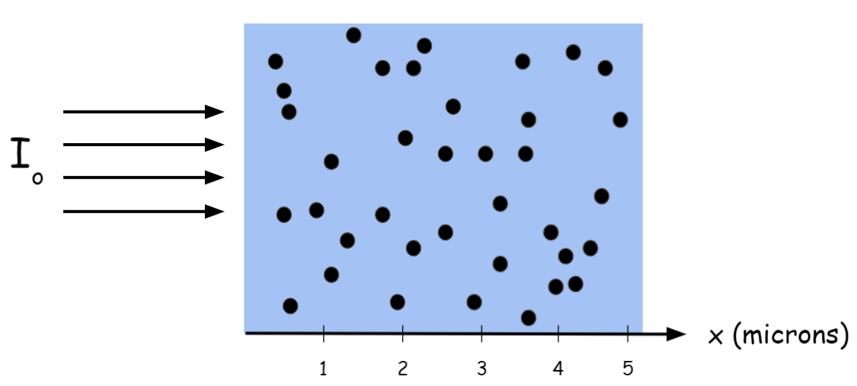Below is a diagram of the previously described experiment involving Cu and Ti. Again, for simplicity assume that the sample is so thick that all of the incident x-rays are absorbed. On the empty graph below the diagram, show how many of the Ti atoms are excited for different penetration depths of the x-ray beam.
3. Assume our goal is to measure the Cu XAFS and we want to do it using fluorescence mode XAS on this sample. We know that trying to directly measure the variations in from the Cu will be problematic. Consider your answers to the previous three questions and describe a method that would allow us to measure the Cu XAFS in fluorescence mode that **does not** rely on looking at the **Cu** . To help you with this, there are four plots below: The correct XAFS spectrum of Cu, the fluorescence mode signal of Cu, the fluorescence mode signal of Ti, and the inverse of the fluorescence mode signal of Ti. The first plot is filled in for you, complete the other three plots and use them as the basis of your explanation of inverse fluorescence mode. Note that the energy scale is the same for all four plots!

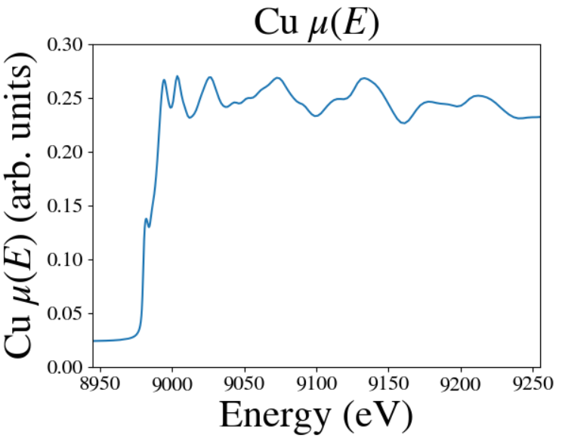 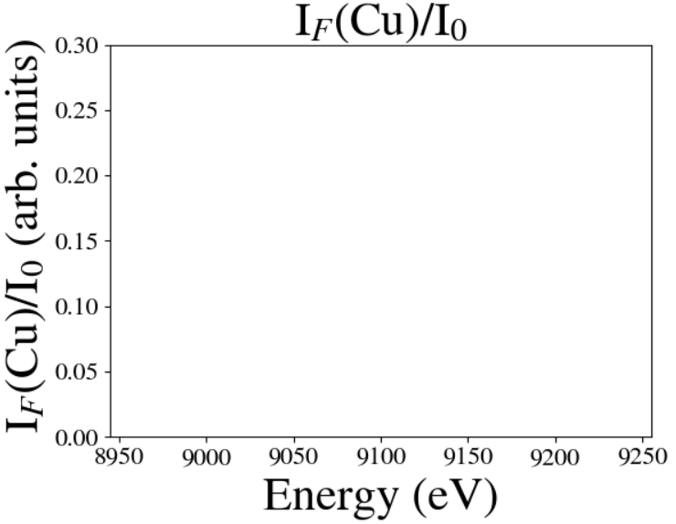

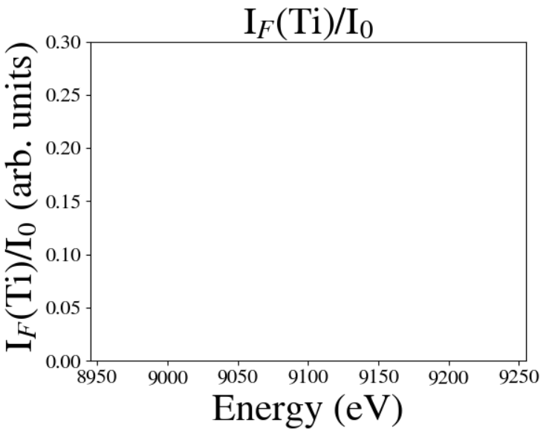 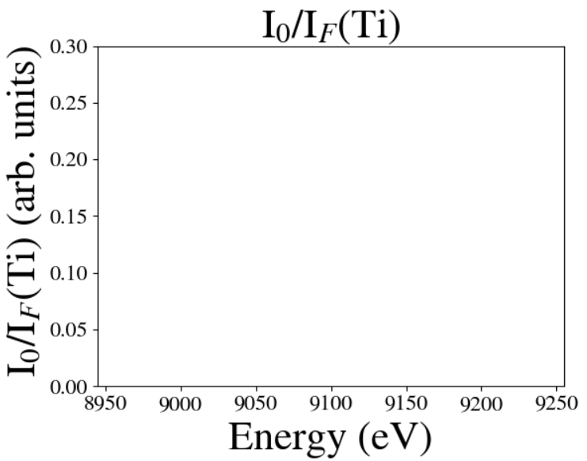

1. The immediately preceding problem gives you the core principle of the inverse partial fluorescence yield (IPFY) method. The signal from the dilute species is (reasonably) proportional to the penetration length, which is itself the reciprocal of the desired absorption length. Read the original paper on IPFY, <https://doi.org/10.1103/PhysRevB.83.081106> , and do a forward literature search to look for papers that use this method. List three of them below. For each of these papers, describe the edge and element being studied, the relevant edge and element that is the dilute ‘signal’ species, and describe why IPFY was a good choice in each case.